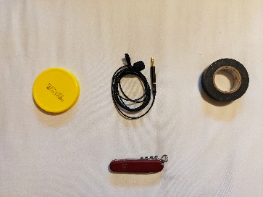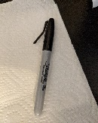

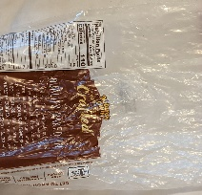**Step 1:** Gather materials.

1. Lid at least 50mm diameter
2. Microphone/headphones with built-in microphone
3. Tape (electrical is preferred)
4. Knife or Scissors
5. Permanent Marker
6. Plastic bag

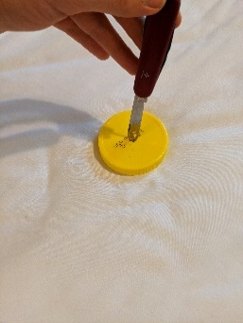**Step 2:** Cut hole into lid.

* Ensure hole is cut large enough to fit the microphone through it.

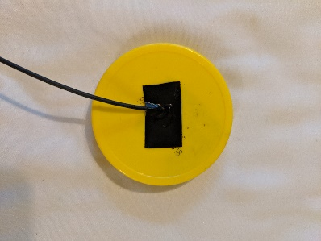

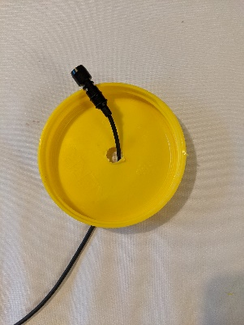**Step 3:** Thread microphone through lid and secure.

* Tape down microphone to the lid but do not cover the microphone port.
* Cover the hole completely so that once the membrane is attached, it is airtight.

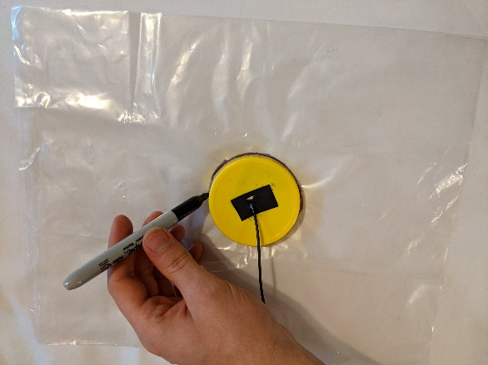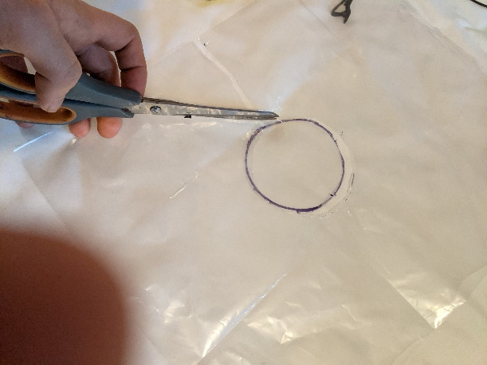

**Step 4:** Trace a circle and cut out.

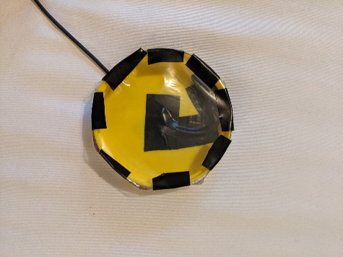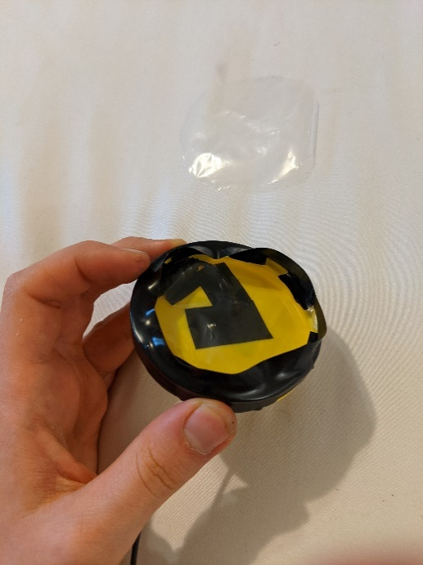**Step 5:** Tape the plastic circle to the front of the lid and secure.

* Ensure the membrane is fully attached and airtight.

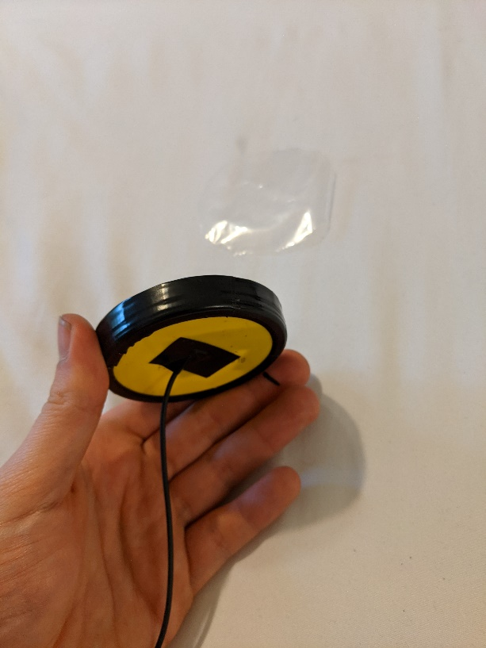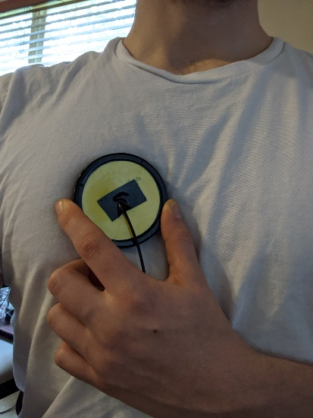**Step 6:** Clean up and record locally or on heart.ai!